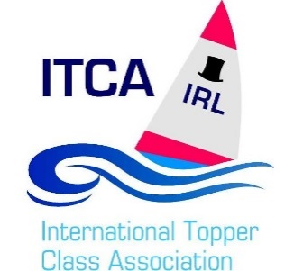

The overall Topper (IRL) Champion and ranking score is based on a combination of the sailor’s results at Irish events over the competition year. The sailor with the lowest score is deemed to be the overall winner and the positions in the table indicate their overall ranking.

The overall score is the total of the following components with weightings applied:

1. **3 Days - Irish Nationals – one event scheduled**
   * **Irish Nationals result are multiplied by 3 +**
2. **2 Days - Provincial - Four events Scheduled**

Winter Regatta, Sourthern, Northerns

* **Best Two results multiplied by 2 +**

1. **1 Day - Travellers - generally four events scheduled**

Where four or more travellers are completed in any one competitive year the following rule applies.

* **Best 2 results multiplied by 1**

Unless where 3 or 2 travellers are completed in any one competitive year then the following rule applies

* **Best 1 result multiplied by 1**

Unless where 1 or less traveller is completed in any one competitive year then the following rule applies

* **No results will count**

**The series will be up to and including the last two day event of the year at which point a winner will be declared.**

Where a sailors takes part who is not a yearly member of the Topper Ireland ITCA, in an Irish ranking event, for scoring purposes their position will be removed and Irish sailors below will be adjusted accordingly.

If a sailor did not compete in an event, a DNC score will be given as follows:

• DNC for Nationals is the number of entries + 5

• DNC for 2-day event is the event with the highest number of entries + 5

• DNC for Traveller event is the event with the highest number of entries + 5

*Please note that the overall DNC score may increase on the last event if there is a larger turnout that in previous events

**Representation at ISA All Ireland Junior and Girls Sailing Championships**

* Representing the Class at the ISA All Ireland Junior & Girls Sailing Championships and other invitation events. Sailors shall be chosen based on the event criteria set out in their specific NoR to represent the Topper class.
* If no criteria is given then it will be on their Topper ranking score at the time the event require topper nominations to be supplied. The class policy is that both boys and girls will be represented where more than one place is available. The current ranking on any day will be computed by reference to the events completed by that day based on the calculations detailed above.
* We will only consider the number of boats eligible to win the title of Irish Champion in calculating the qualifying attendance.